Miles Porter – Tu/Th

CS 2050 Technical Documentation
w
General Resources
Development Environment
Language Fundamentals:
Parts of a Java Program
Operations and Evaluating Expressions
Version Control and IDE
Primitive Data Types and Casting
Predefined Classes, Objects and Methods and I/O
Math Class, Characters and Strings
Decision Structures: if and if / else
More Decisions and Logical Operators
Switch statements:
Loops
Do / While Loop
While Loop
For loop
Nested For Loop
Methods
Method signature:
Calling methods:
Chained Method call:
Arrays
Declaring Arrays:
Passing and Returning Arrays
Copying Arrays
Memory
Pass by Value
Pass by Reference
Static Variables
Static Methods
Encapsulation
Polymorphism, Inheritance, & Big-O Notation
Polymorphism
Inheritance
Method Overloading
Method Overriding
Abstract Classes
Dynamic Binding
Big-O Notation
Sorting Algorithms
Searching Algorithms
File Input Processing

General Resources
Your first source should always be:
- Your class lecture slides, documents and the resources linked in the canvas materials, instructor (Deb), learning assistant (LA)
If you need extra clarification or examples you can use these but always compare with the lecture information.
- Runestone Academy – CS Java (interactive book):
https://runestone.academy/ns/books/published/csjava/index.html
- GeeksforGeeks Tutorial– Programming Concepts & Java:
https://www.geeksforgeeks.org/java/
- Oracle Official Docs – For advanced lookups:
https://docs.oracle.com/javase/tutorial/java/index.html

If you're unsure whether a source is trustworthy, ask your instructor first.
⚠️ Avoid These Sources
- TPointTech https://www.tpointtech.com/
- W3Schools – Java, syntax, data types, etc.:
https://www.w3schools.com/java/
- Sites without a known author or date
- AI-generated blogs that do not cite documentation

Tools:
- Visualize Java Code - used to step through code and edit code

Feel free to add more resources shared from the lectures.

Development Environment
Summarize version control and Integrated Development Environment .Include an images you think is helpful and include the link to the website containing the image

Language Fundamentals:

Parts of a Java Program
public class ComputeArea {
public static void main(String[] args) {
//declare and initialize constant in read only memory
final double PI = 3.14159;
//declare variables will allocate memory based on data type.
double radius;
double area;

radius = 20;

double area = radius * radius * PI;

System.out.println("The area for the circle of radius " +
radius + " is " + area);
}//end of main
}//end of class

- Keywords are defined already for java: public ,class, static, void, final, double
- Identifiers are names made by the programmer for classes, methods, variables and constants
  - Camel case is how you write the names with multiple words
  - Use meaningful names
  - Use correct naming conventions Naming Conventions - Java
    - Classes start with capital letter: ComputeArea
    - Variables start with lowercase letter: radius
    - Constants all uppercase with _ to separate words: PI
- Every program has a class :
  - Has { where class block starts and } where it ends
  - Example: ComputeArea
- Inside the class is the main(String[] args) method
  - Has { where main method block starts and } where it ends
  - Method block contains code statements that will run
- Print methods
  - It prints what is in the parenthesis in quotes “” and in the variables
  - + is used
    - Example: System.out.println("The area for the circle of radius " + radius + " is " + area);
- A literal is a fixed value used in code
  - example 3.14159, 20
- Variables store different types of data in memory
  - The data type: determines how many bytes to store that type of data such as double or integer which are
  - primitive data types
  - Declare variables with data type identifier to allocate memory
    - Example: double radius;
  - Initialize a variable means to assign the first value to store in memory
    - Example radius = 20;
  - The = means assign what is on the right and store in memory identified by name on the left
  - You can declare and initialize in one step
    - Example: double radius = 20;
  - Always initialize variables before using
- Constants store values in read only memory because the don’t change:
  - When declaring a constant use the final keyword then the data type before assigning
  - Example: final double PI = 3.14159;
  - Use all caps identifier for constant
- Comments are used to explain code
  - Ways to write Java Comments
  - Example: //end of main
Resources:
- M01 L02 Language Fundamentals
- 1.3. Variables and Data Types — CS Java

Operations and Evaluating Expressions
Order of Operations:
  - Parenthesis
  - Exponents
  - Multiplication / Division (Left to right)
  - Addition / Subtraction (Left to right)
Some other operators used in coding are:
% = Mod operator shows remainder after division ( 20 % 6 = 2 because 6 goes into 20 3 times with 2 left over)
- is used to determine even or odd numbers in coding ( variable % 2 == 0 is even, variable % 2 == 1 is odd)
|| = or
&& = and
!= = not equals
“==“ = literal equals
“=“ = assignment operator, not “equals”
< = less than
<= = less than OR equal to
> = greater than
>= greater than OR equal to
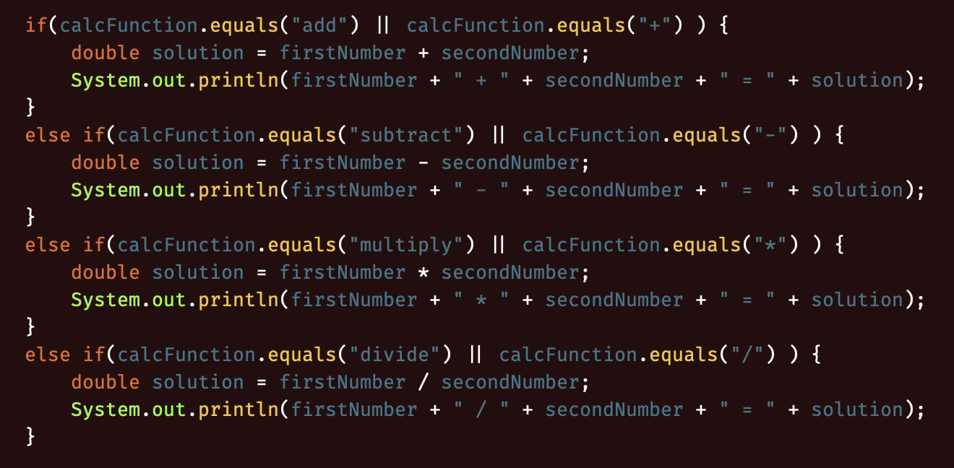

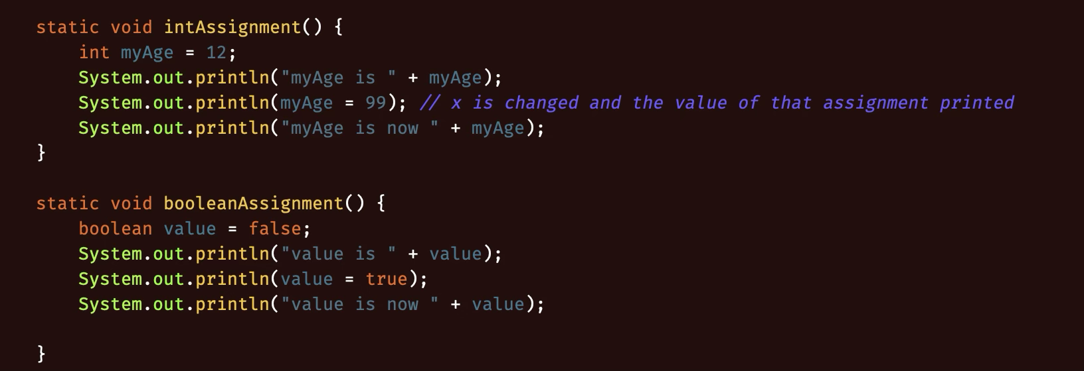
Organize your documentation for L03 below. Create headings and add explanations with code examples.

Version Control and IDE
Git provides version control for your files
Allows for you to roll back files to older versions if something breaks
Work in branches

GitHub provides a cloud based service to store your local Git versions of files;
Can collaborate with pull/push/merge while avoiding issues or reverting if breaks
Repositories(local and remote) are locations where versions are stored
Always provide detailed commit messages

Primitive Data Types and Casting
Data types can be implicitly cast to a larger data type( ie, int to double, int to long, etc)
Must be explicitly cast to a smaller data type ( double to int)
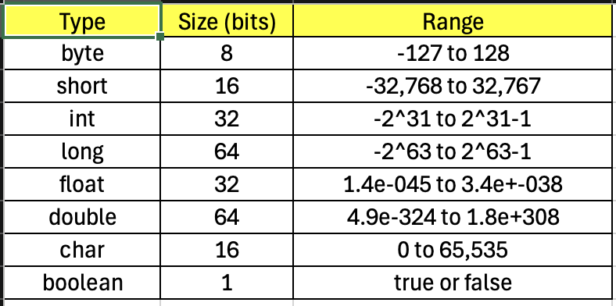

Predefined Classes, Objects and Methods and I/O
Predefined classes include, but are not limited to, Scanner, Math, System, etc

Most predefined classes need to be imported into the class in order to be used

Predefined methods are methods such as println() for System, random() for Math, and next() from Scanner. These methods are built into the JDK

printf() formatting:

Specifier | Output | Example
%b | Boolean | True / False
%c | Char | ‘A’
%d | Decimal integer | 100
%f | Floating-point number | 99.99
%e | Scientific notation number | 4.556000e+01
%s | String | “Insert String here”

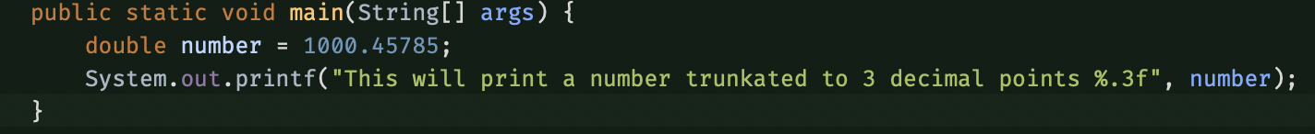

Escape Characters

- \b
  - Backspace
- \t
  - Tab
- \n
  - Linefeed (New line)
- \f
  - Formfeed
- \r
  - Carriage Return
- \\
  - Backslash literal
- \”
  - Double quote literal

Classes = blueprints
Objects.= instances of classes that can have their own attributes as well as inherited ones

Math Class, Characters and Strings
Math class:
- Private constructor, so objects cannot be instantiated
- All methods are static
- Use class name to call static methods, i.e. Math.random()
- Math methods:
  - PI()
    - Constant value of pi
  - Abs()
    - Absolute value
  - Max(a, b)
    - Larger of two numbers
  - Min(a, b)
    - Smaller of two numbers
  - Pow(x, y)
    - X raised to the power of y
  - Sqrt(x)
    - Square root
  - random()
    - returns a random double in range of 0.0 <= x < 1.0
Method overloading is when there are 2+ methods with the same name, but different parameters

Char – a single character, i.e. ‘a’, ‘b’, ‘1’, ‘!’

String – an array of characters, i.e. “Hello, world”
- String.charAt(x)
  - returns the character located at index x in the string
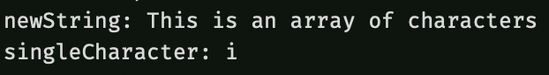

Decision Structures: if and if / else
if (boolean) {
Code to execute if true
} else if (another boolean) {
Code to execute if this boolean is true
} else {
Code to execute if none of the above conditions are met
}
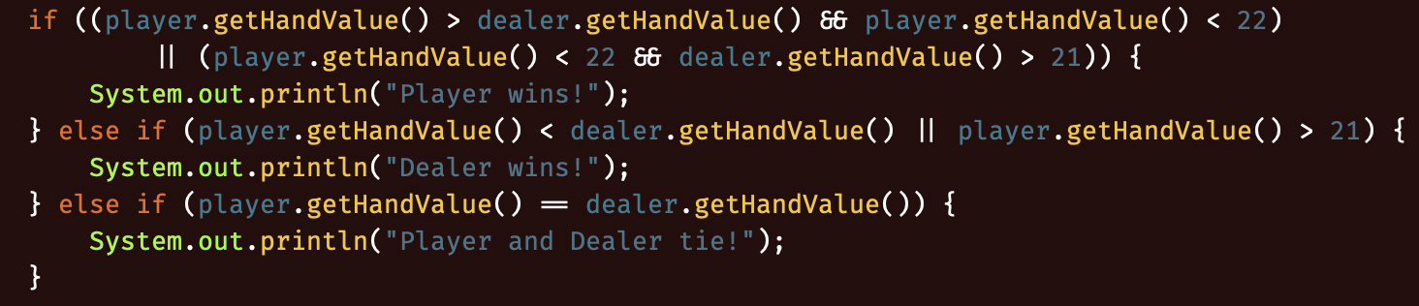

More Decisions and Logical Operators
Nested if / else statements: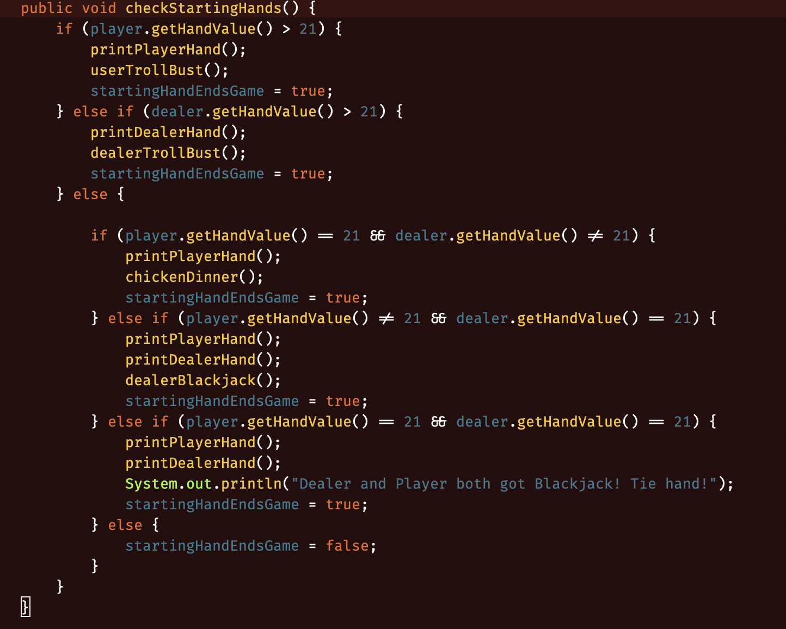

Switch statements:
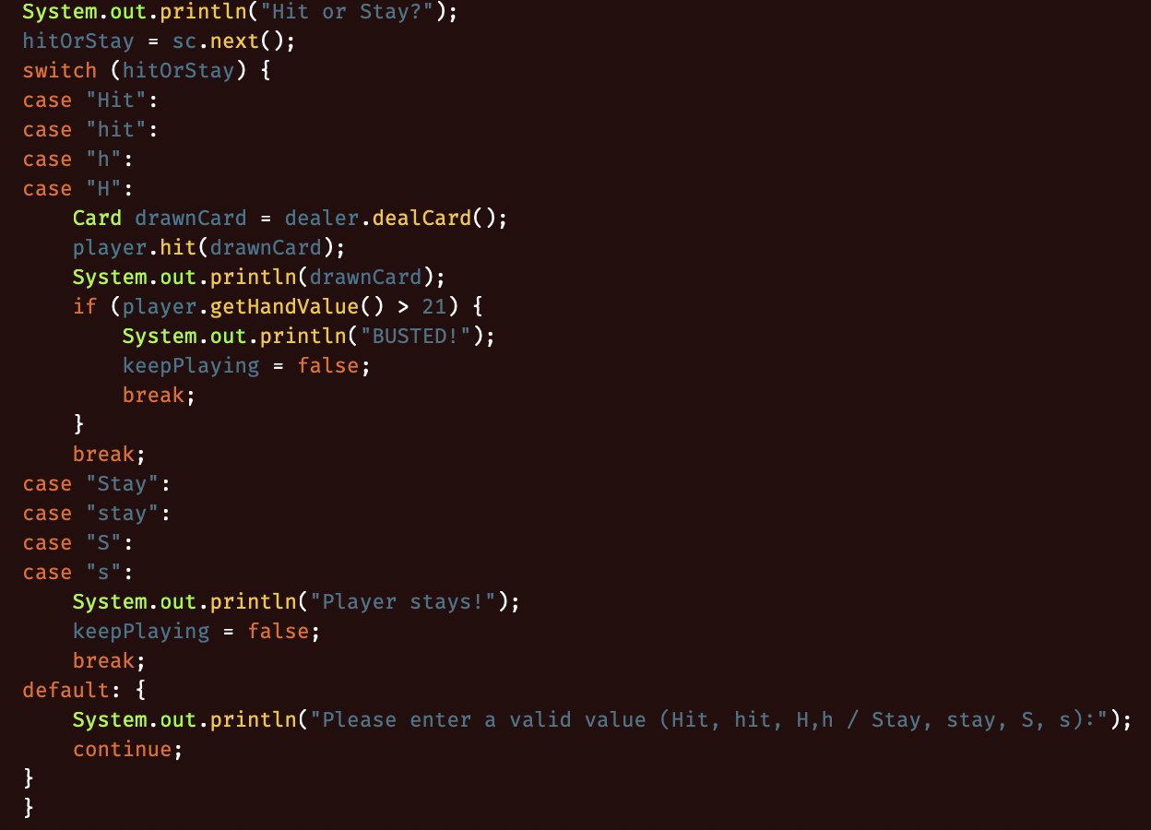

Loops
Pre(++someInt) vs Post(someInt++) increment / decrement
- Pre:
Increment/decrement is carried out before the variable is used
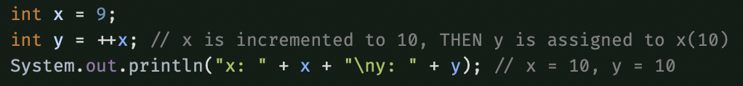
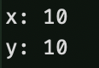
- Post:
Increment/decrement is carried out after the variable is used
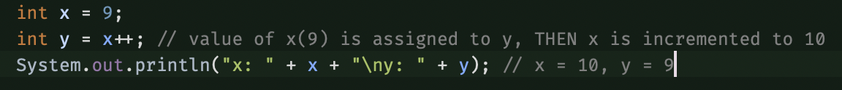
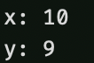

Do / While Loop
- Will iterate at least one time, checking the condition after the end of each loop
- Useful for when you don’t know how many times you want a loop to iterate, but you know you need AT LEAST one iteration
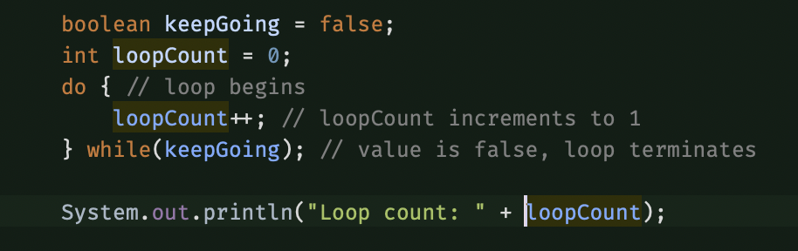
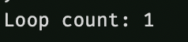

While Loop
- Checks condition before start of each iteration
- Loop runs anywhere from 0 to infinite times
- Useful for when you don’t know if a loop needs to run at all, or how many iterations are needed if it does
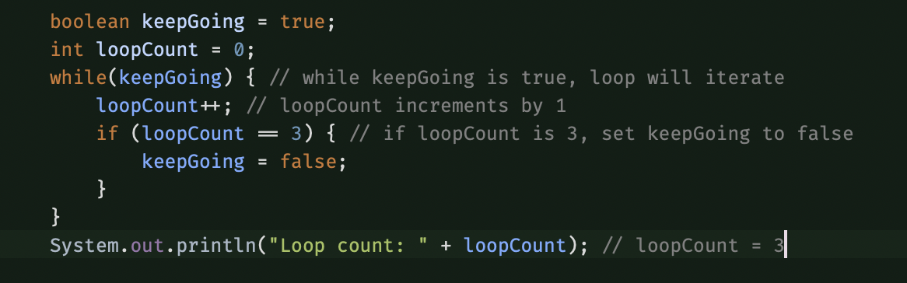
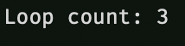

For loop
- Iterates through the loop for a predefined number of iterations
- Useful for when you know how many iterations you need to run
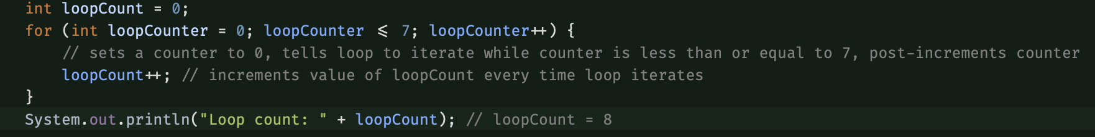

** Note on this output **
This outputs 8, because the loop checks if the counter is less than or equal to 7, and the counter increments AFTER each loop iterates; so, the loopCount increments to 8, then the loop is done, so loopCounter increments to 8; Next time the condition is checked, the loop terminates and the count is 8. If this had read loopCounter < 7, the loopCount would print 7 instead.

Nested For Loop
- You can put loops within loops
- Inner loops will run through their entire process each time the outer loop iterates
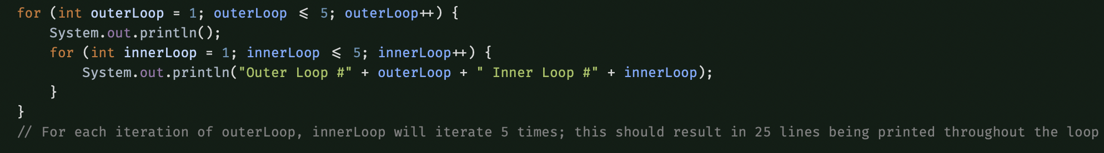

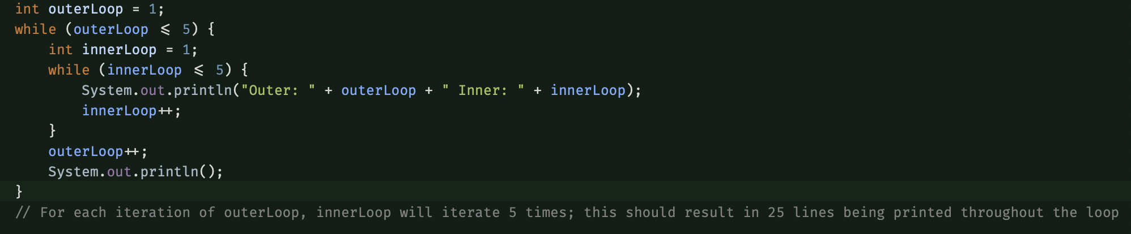
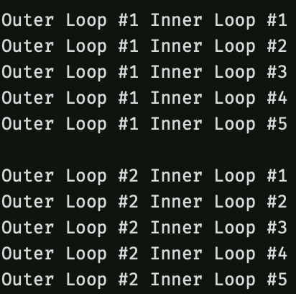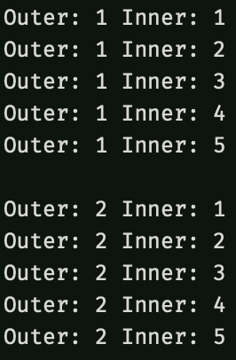

Methods

Method signature:
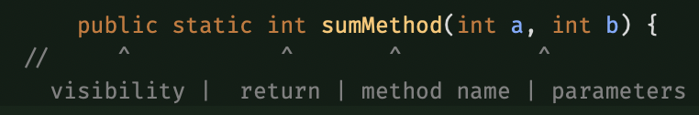

Calling methods:
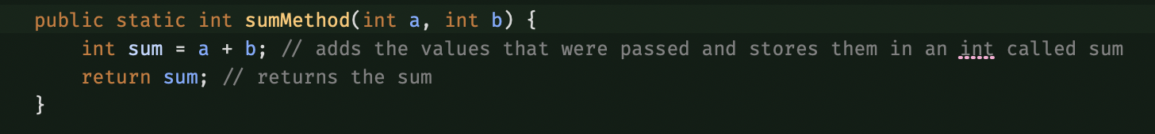

Chained Method call:
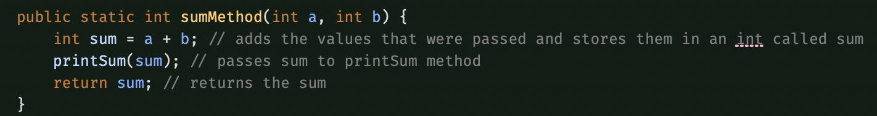
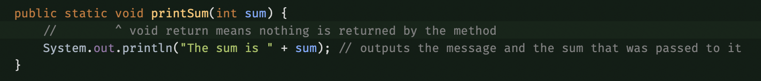

Arrays

Collection of objects stored next to each other on the heap
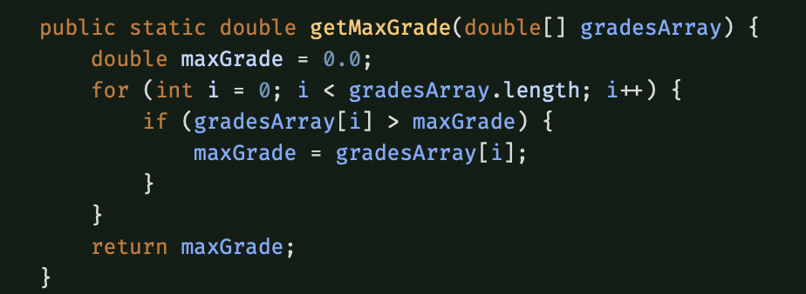
This example steps through the contents of an array and compares them to a value, replacing that value with the contents of the array index if the condition is met

Declaring Arrays:
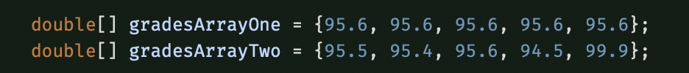

Passing and Returning Arrays
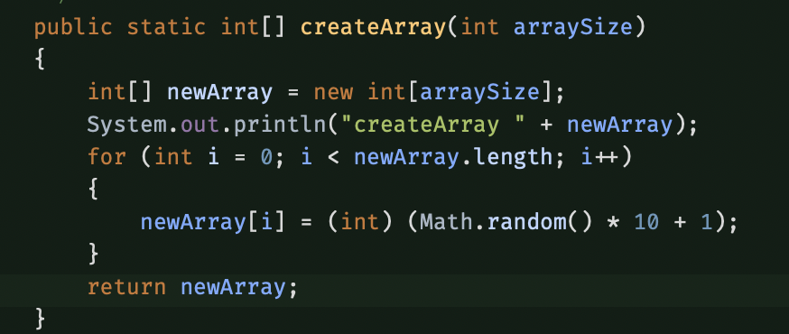
This passes the reference variable for the array in each circumstance, not the actual value stored there

Copying Arrays
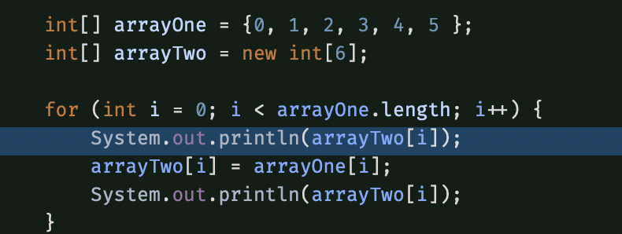
This assigns the values stored in arrayOne to the same index of arrayTwo; Demonstrated by printing the value of arrayTwo[i] before AND after each copy function, to show the value successfully changing

Memory

Pass by Value
  - Passes the value of a variable, not the actual stored variable itself
  - Changing the passed value does not change the original stored value

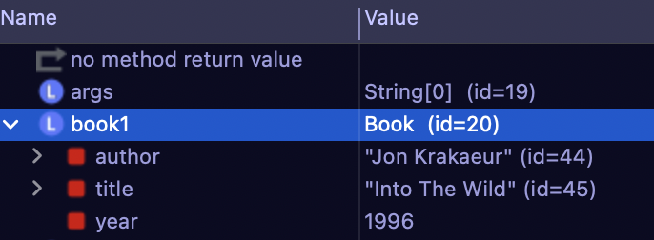
Shows how primitives are stored(value : ie: year 1996), and references(ie : Book id= 20)

Pass by Reference
- Passes a reference variable(address to the object on the heap)
- Making changes to the passed referenced object changes the stored object, hence changing the original passed variable as well

Static Variables
- Variables shared by all objects of a class
- Only one copy of a static variable exists, no matter how many instances of the class exist
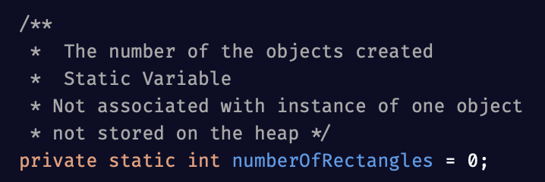

Static Methods
- A method shared by all objects of a class
- Does not need an object to be instantiated to be called
- Can call static methods using Class.Method() notation
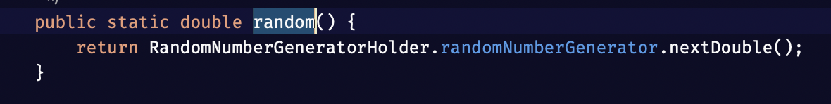

Encapsulation
- The concept of keeping fields and/or methods private, and restricting access to allowed fields by using getters and setters to access or modify fields
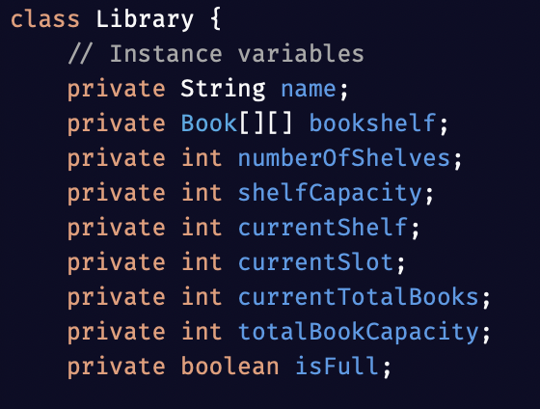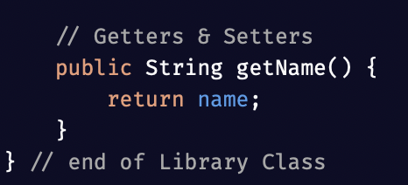

Polymorphism, Inheritance, & Big-O Notation

Polymorphism
  - Allows one superclass reference type to point to different subclass types
  - Allows the same method call to behave differently depending on the object type calling it
  - Makes programs more flexible and easier to enforce SRP
  - Dynamic binding is used to choose the correct version of the method at runtime

Inheritance
- Allows a subclass to reuse fields and methods from a superclass
- Helps with DRY and improves organization
- Subclasses are created using extends keyword


Method Overloading
  - Defining different variations of a method that all share a name, but have different parameters
  - Java decides which overloaded method to use based on which parameters match the method being called
  - Constructors are often overloaded
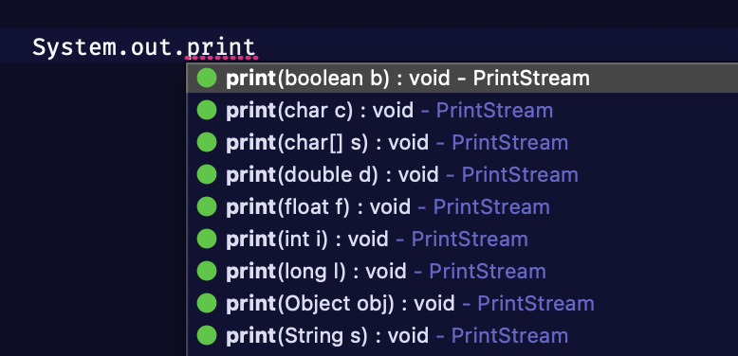

Method Overriding
- The practice of re-defining a method within a subclass, using the same name and arguments, with the @Override annotation.
- Java will choose which version of the method to run at run-time, based on the subclass type that is calling the method in question
- Used to define variants of methods within different subclasses of a single parent class
- All abstract classes MUST be overridden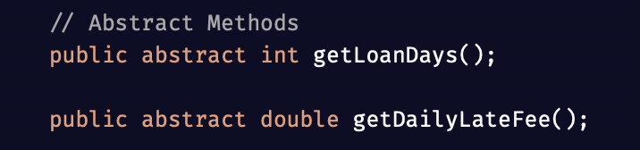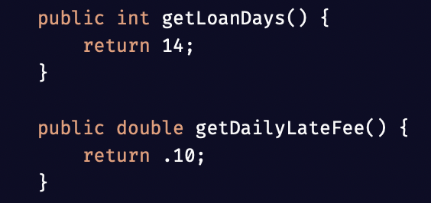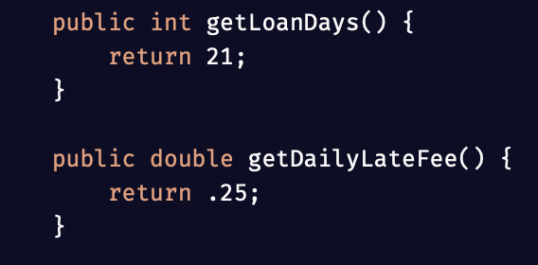

Abstract Classes
- Classes that cannot be instantiated
- Used to define shared data and behavior for subclasses
- Abstract methods have no body in the superclass
  - Must be overridden in subclass
- Help enforce structure across subclasses
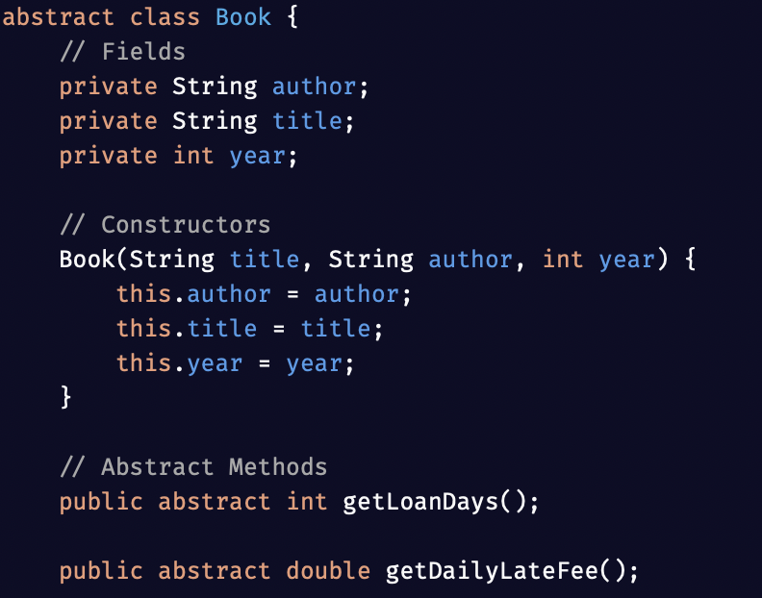

Dynamic Binding
- Java chooses correct overridden method at runtime
- Decides based on object type, not just reference type
- Makes polymorphism possible
- Improves flexibility by supporting reusable code

Big-O Notation
- Describes how algorithm performance changes as input size grows
- Focuses on efficiency
- 0(1) means constant time, 0(n) means linear, and 0(log n) means logarithmic
- Useful for comparing algorithms and predicting scalability

Sorting Algorithms
- Selection sort repeatedly find the smallest value and places it in the correct position
- Insertion sort builds a sorted section, one element at a time
- Both selection and insertion sort algorithms have a worst case Big-O of 0(n^2)
- Insertion performs better than selection if the list is nearly sorted
- Sorting makes other algorithms more efficient, such as searching with binary search

Searching Algorithms
- Linear search checks indexes one at a time until the key is found
- Binary search divides a sorted list in half repeatedly
- Linear search works on both sorted and unsorted arrays
- Linear search is 0(n)
- Binary search is 0(log n)

File Input Processing
- Allows a program to read data from an external file
- Commonly handled with Scanner class
- Data read from files can be stored in arrays or used to instantiate objects
- Input validation ensures data is complete and correct

